**EXPERIMENT 12**

**CURSORS**

**Aim:**

* Create a table with attributes students and marks.
* Insert values into the table.
* Create a procedure, and fetch the marks of given id using a cursor.
* Create a procedure, and fetch the highest marks using a cursor.

**Components:**

* A cursor is activated and created in response to any SQL statement.

**Schema:**

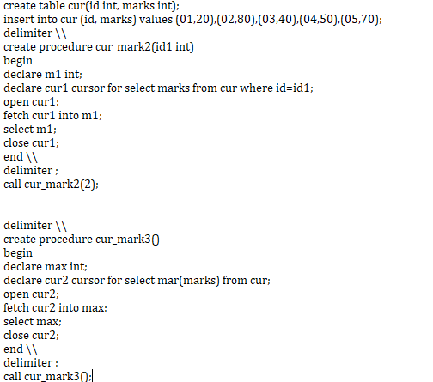

**Output:**

